August 12, 2018



TITLE: FRONT-END SOLUTIONS FOR INTERNET OF THINGS APPLICATION.

enterprise information systems

class assignment

Anshika Banerjee

10372825

MSc. Information Systems with Computing (Jan 2018)

|  |  |
| --- | --- |
| MODULE NAME | Enterprise Information System |
| MODULE NUMBER | B9IS104 |
| LECTURER NAME | Paul Laird |
| STUDENT NAME | Anshika Banerjee |
| STUDENT NUMBER | 10372528 |
| COURSE NAME | MSc. Information System with Computing |
| ENTERPRISE INFORMATION SYSTEM APPLICATION TOPIC COVERED. | Oauth Authentication and Web Services |
| LINK TO GITHUB REPOSITORY | <https://github.com/anshikabanerjee/EIS-10372528-CA2> |
| LINK TO PWA HOSTED ON A OPEN SOURCE SERVER | <https://cantabrigian-peak.000webhostapp.com/index.html> |

Table of Contents

Abstract 3

1. Introduction 4

2. Aim 5

3. Objectives 5

4. Design 6

5. Methodology 9

# Abstract

The artefact is a one-point solution for IOT applications. It provides a front-end outlet to which any IOT application who wants to display and interpret data can use. The artefact is meant for the user to correctly understand the data generated by the devices/ sensors. The artefact will do certain amount of analysis with the live data. This function will be achieved via Google Analytics API. The data will be obtained from ThingsSpeak.com. The website is an opensource platform for uploading IOT data. And for the purpose of the stimulation of the PWA, we will pull data from this website onto our PWA. The PWA will encapsulate all web services within itself. The login into this Web App will be through OAuth via a Google account.

# Introduction

This artefact facilities front end solutions for all IOT (Internet of Things) applications. The data generated by the IOT device or sensors will be streamed live into our Progressive Web Application and displayed in a user-friendly manner.

The Progressive Web Application or (PWA) is a hybrid of a regular web pages (or websites) and a mobile application. This new application model attempts to combine features offered by most modern browsers with the benefits of mobile experience.

The need for the artefact is dire as stated “The number of IOT devices increased 31% year-over-year to 8.4 billion in 2017(*Große internationale Allianz gegen Cyber-Attacken*, 2016) and it is estimated that there will be 30 billion devices by 2020. The global market value of IoT is projected to reach $7.1 trillion by 2020.” (Nordrum, 2016).

OAuth Authentication technique will be used to make the web app secure. For OAuth to work the user needs to own a google account. In this manner the OAuth authentication will confirm the legitimacy of the user and approve their access. Thus, this artefact will be secure form invalid users.

# Aim

The main aim of the project is as follows:

1. To fulfil the criteria of the Enterprise Information Systems Class Assignment.
2. To have a secure system.
3. To provide Web Services to IOT devices.
4. To make a system which is easy to be used by every user.

# Objectives

1. To fulfil the criteria of the Enterprise Information Systems Class Assignment, the artefact incorporates Oauth authentication and uses APIs from different platforms in the form of web services.
2. The Artefact itself is an attempt to provide web services. It can be used with any IOT device and facilitate its frontend for it.
3. The Artefact uses Oauth to provide attention services. It authenticates the users. And thus, renders the safe use of the application.
4. The PWA is designed such that the users will find it easy to navigate through the site. It provided with a simple GUI.

# Design

The artefact is built as a PWA. According to a study done by (‘Progressive web apps: key benefits, statistics, use cases’, 2017) PWAs are the best innovation which capacitates the benefits of both a mobile app and a website.

The PWA pulls data from ThingsSpeak.com. Things Speak open source platform provides an API setup to pull the live data from their servers to our PWA Setup. A specific channel will be built to handle this data. A channel is setup between ThingsSpeak.com and our Artefact, the API controls the flow of data. The data streaming is attempted to be done live. This feature is be achieved with the help of the ThingsSpeak.com server and Kafka Server which is a server used for live data streaming. The data transfers take place in the following ways, parent site will generate a CSV, XML or JSON data file to be transported and displayed into the PWA. The generated file is transported to google sheets. Google sheets generates and performs analytical operations on it and this report is pulled into the PWA via Google Sheets APIs.

We have narrowed down to 3 specific channels from where we want to pull data from. The links to these channels has been provided in the Appendix. These three channels have very different and varied data. Once the artefact is built. The true usefulness of the PWA will be seen.

Google API will be used to display and work with that data. For example, Google Analytics and Google Graphs will be used. Once the data is in the Web App, we will run it through the Google Analytics API and get certain patterns.

OAuth Authentication techniques will be deployed on to this application to make it more secure. They say “Data is the new oil for our century.” And that is why we need to make sure the IOT data is made secure. OAuth will help in this area.

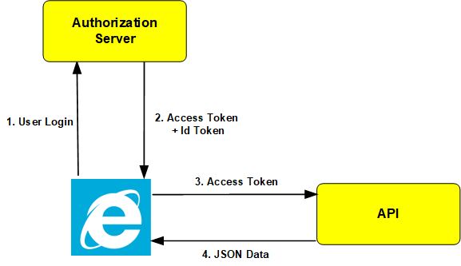

Figure: The Working of Oauth within the artefact.

The Authorization Server, the artefact is using the Google Authentication Services via a “Gmail.com” email address. As seen above in the diagram the Web browser sends the user login request to the Authorization server. This is done so by, the user entering their Gmail credentials. The username and passwords of the user are sent to the Google Authentication server to be verified. The server then sends the access tokens and Token Id back to the web browser if the user is successfully verified.

The access token obtained from the Authentication server is then sent to the API to retrieve data. Data in our artefact can be obtained in the form of JSON, XML and a CSV file format.

Thus, the above diagram depicts the way the Oauth service works. In this was the artefact is able to provide a secure service to the user of this application.

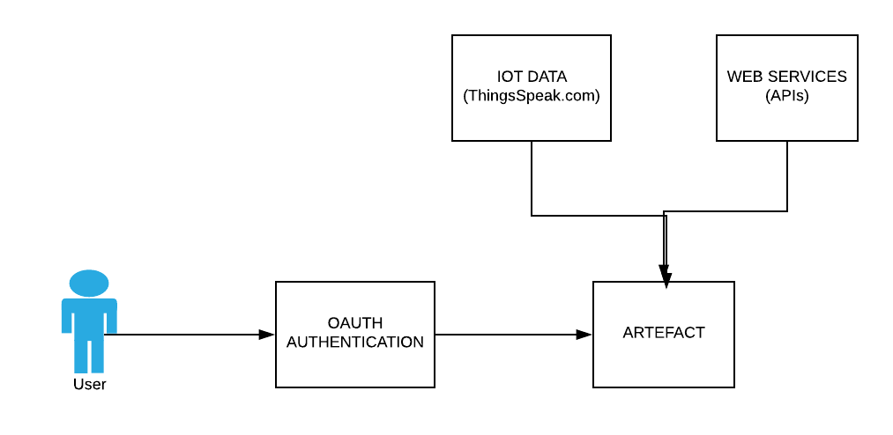

Figure: The flow of the artefact.

The above figure shows the flow of the proposed system. The applications or artefact will have an initial oauth authentication page which will allow the user to verify himself. The authentication can be done via a Google account. In the future scope of this application the authentication can be done via Facebook LinkedIn, GitHub.

The artefact is connected to the ThingsSpeak.com server and multiple Web Services. In the figure above how, the artefact is connected to the oauth Authentication information system and the different Web Services.

Together with all the above setup it provides web services to the user as a whole.

# Methodology

The development of the artefact was an individual effort. Thus, the Software Development method chosen to work on this project was the waterfall model.

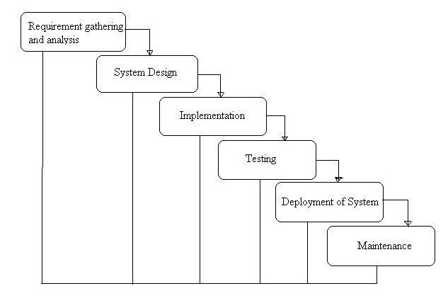

Figure: The Waterfall Model.

* It is a basic, straight-forward approach.
* It is easy to develop a plan for managing a Waterfall project since every stage has a starting point and an ending point.
* The early start to planning provides a good basis for designing components that integrate with external systems. Thus, while incorporating webservices. It proved to be very helpful.
* The cost of development and the feasibility of the project was resolved ahead of time.
* The detailed procedures were used to regulate every part of the process.
* The reliance on design, documentation reduced the stress from development and allowed more time to focus on the important stages of the Project.

While the development of the project all the aspects of the waterfall model were kept in mind and then implemented. Each stage was given ample time to complete and then reviewed, before proceeding into the next stage.

Requirement Gathering

System Design

Implementation

Testing

Deployment of System

Maintenance